### 15th February 2016

### YOKOHAMA starts SNS movie series featuring Chelsea FC players

Tokyo – The Yokohama Rubber Co., Ltd., announced today that it has started a series of mini movies featuring players of the Barclays Premier League Chelsea Football Club, with which the Company entered into a partnership agreement in July 2015. The series’ first instalment was posted to Yokohama Rubber’s YouTube channel（<http://www.youtube.com/TheYokohamaRubber/>）and to the YOKOHAMA Chelsea FC Facebook（<http://www.facebook.com/YOKOHAMACFC/>）and Twitter（<http://twitter.com/YokohamaCFC>） pages on 5th February. The mini movies include a brief animated version of YOKOHAMA’s introductory slide show（<http://www.y-yokohama.com/global/glance/ourstory/>）and Chelsea FC players demonstrating soccer techniques as a means of introducing various YOKOHAMA products and technologies. A total of eight mini movies will be posted, with a new one uploaded every two weeks for the remainder of the Premier League’s 2015–16 season. Available in six languages - Japanese, English, Indonesian, Thai, Chinese and Russian - the mini movies will introduce Chelsea FC fans around the world to YOKOHAMA and will feature content that entertains while also increasing their understanding of and interest in the Company.

The first mini movie, posted on 5th February, features Chelsea midfielder and Brazilian national team member Willian and shows him practicing free kicks. Willian explains that simulating the free kick situation over and over again in practice leads to success in real game situations and relates that to YOKOHAMA’s innovative tyre simulation technologies that contribute to better tyre performance, such as the Company’s groundbreaking flow structure/acoustic wave simulation technology and its aerodynamics technologies.

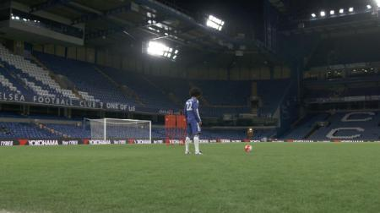

*Willian simulating a free kick situation*

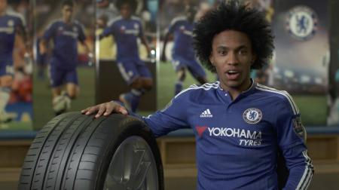

*Chelsea midfielder Willian*